L04 Homework Assignment – Functional Program

Background
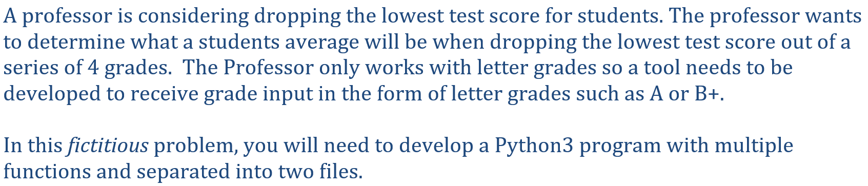

Procedure
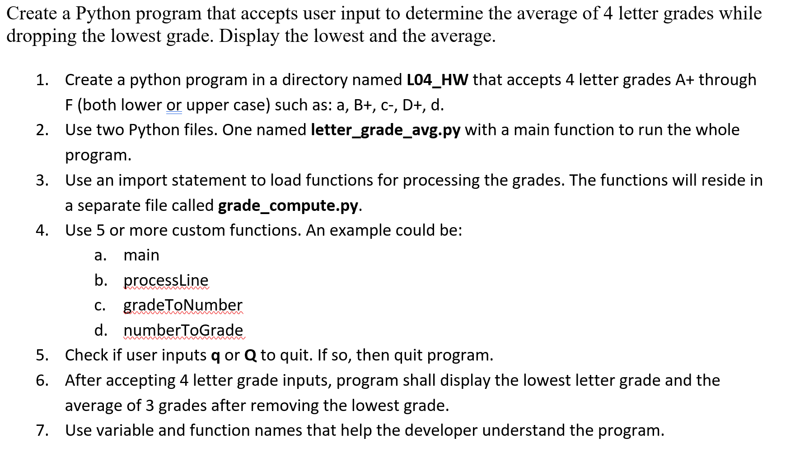
- Use comments for each function or other blocks of important code, for example ## Converts a letter grade to a number.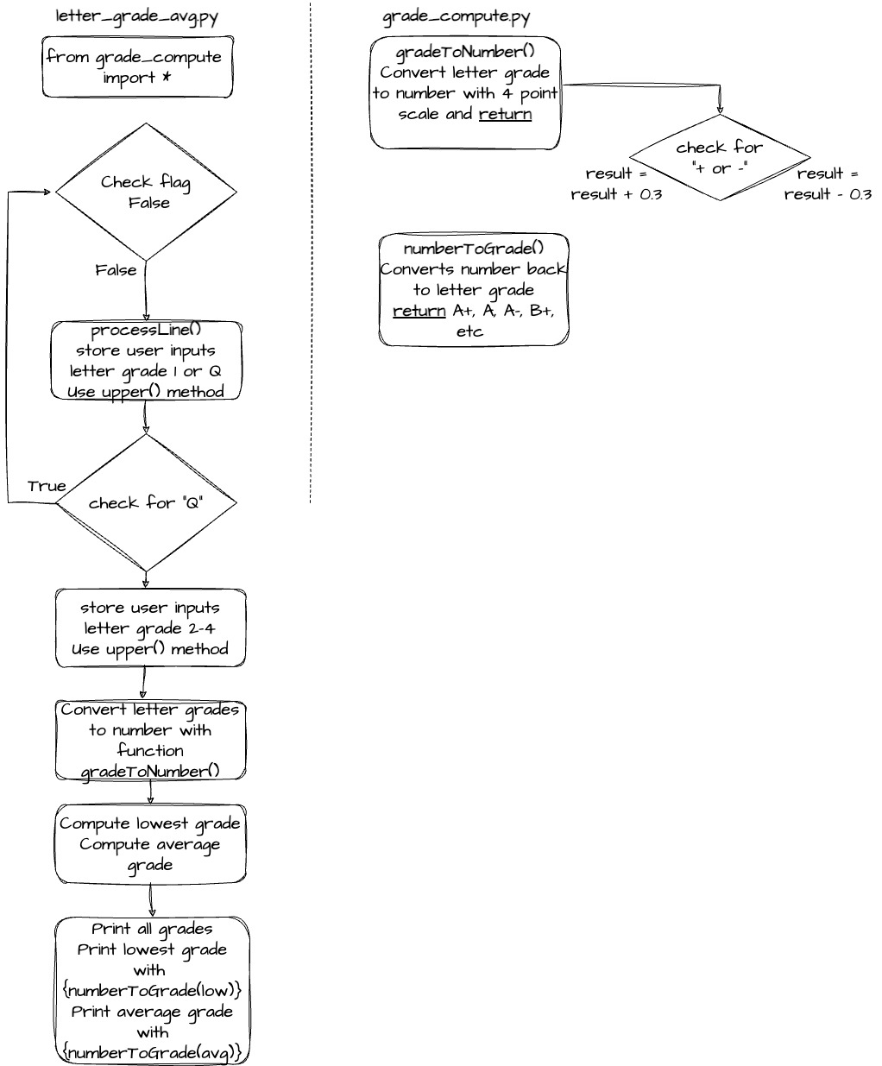

Constraints
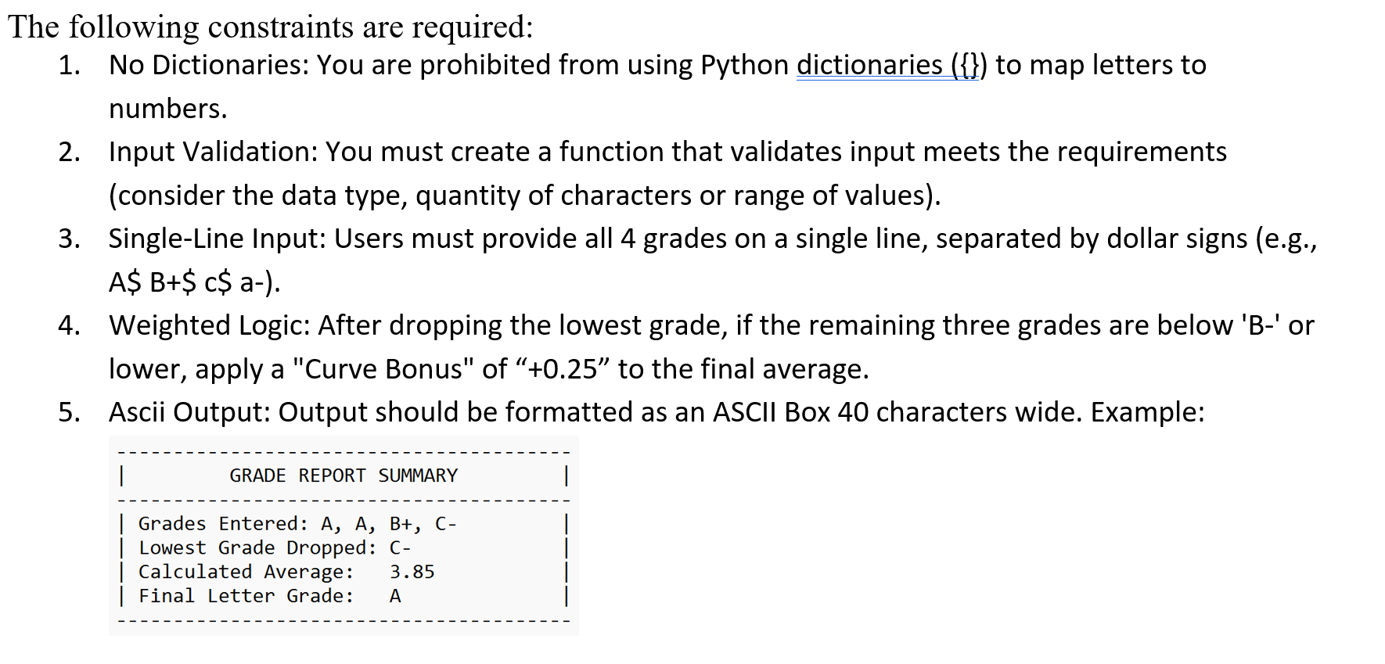
- Submit a screenshot (not zipped) in this word or pdf document that shows user input of 4 letter grades and output of lowest grade and grade average.
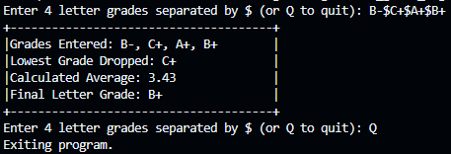

- If you use any AI tools to assist you, include the name of the tool, your prompt, and the AI tool’s output.
- GitHub Copilot
Accepted Copilot tab suggestion for 40-character ASCII summary box

- Word or pdf to include url to your github repository with the Python application. It should include two python files and a readme file.
https://github.com/sutomuz/L04-HW-COP2080-FunctionalProgramming.git

